***Interactive Quiz Application (Team 12)***

***Team Members:***

|  |  |
| --- | --- |
| **Class ID** | **Name** |
| **26** | Makani,Sai Teja |
| **38** | Neelima-Putta,Divya-Sai-Lakshmi |
| **9** | Chinthakindhi,Nikhila |
| **62** | Arun |

**Introduction:**

Interactive Quiz application is a dynamic application which facilitates users to take quizzes online through web portal. Details of the tests taken with their results are accessible to the user at any time.

Users can take tests, retake tests and view written tests results in this application.

**Objectives:**

* Objective is to create user friendly Interactive quiz application with register page, login page and home page using ionic framework.
* Home page would contain tabs for user profile and to take online quiz.
* User would receive an instant score as soon as he/she is done with the quiz.

**Features:**

* User can select topic for quiz from the various topics displayed in the home page.
* User can listen to questions in their quizzes while taking test.
* Scribble pad is available for users for scratch work. It is saved for user’s future use to analyse wrong answers if any.
* Application is built on ionic framework.

**Detailed design of features:**

* **Wire Frames:**

Wire frame design for Start/Index page of the Interactive quiz application is as follows:

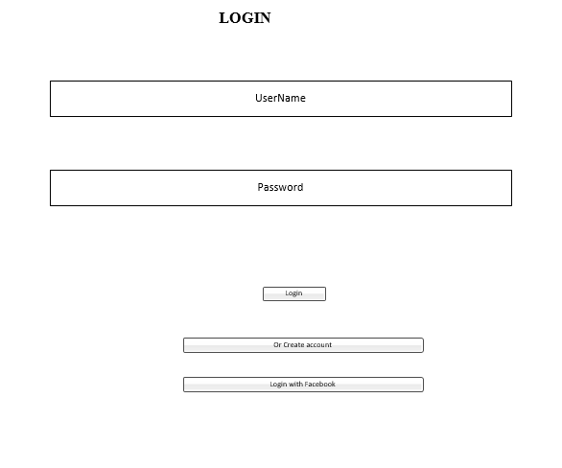

Wire frame design for sign up page of the Interactive quiz application is as follows:

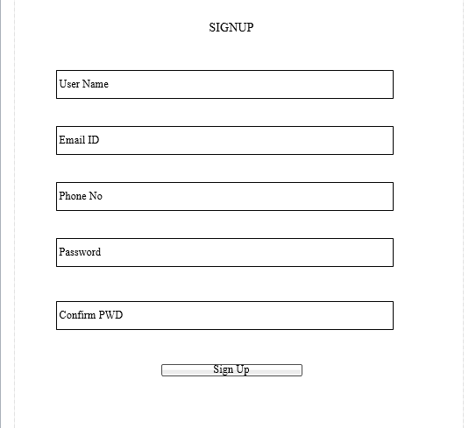

Wire frame design for profile page of the Interactive quiz application is as follows:

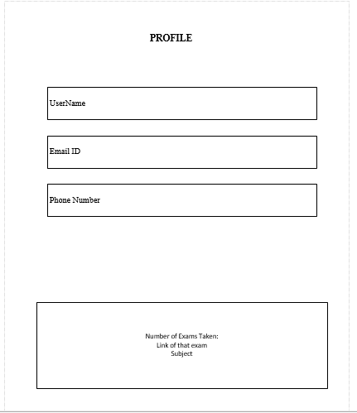

Wire frame design for quiz selection page of the Interactive quiz application is as follows:

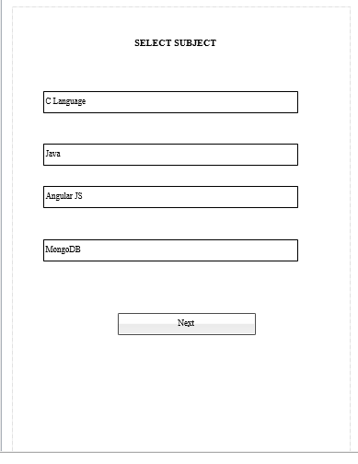

Wire frame design for quiz questions page of the Interactive quiz application is as follows:

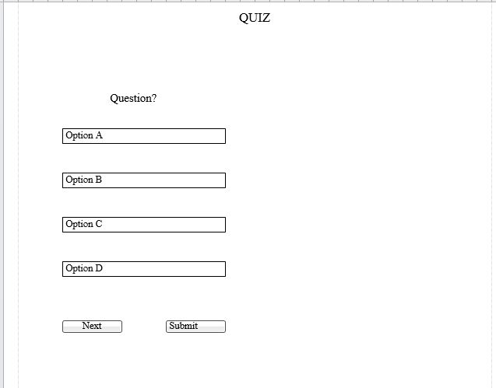

Wire frame design for tabs available in Interactive quiz application is as follows:

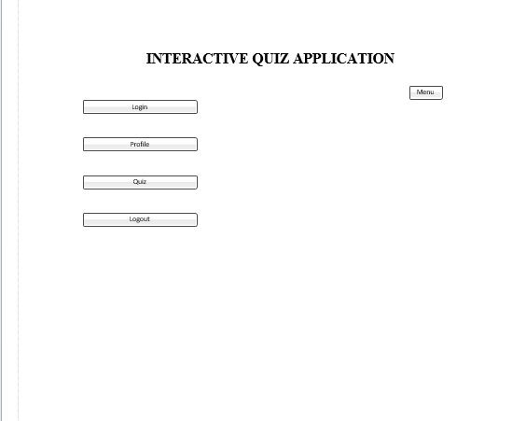

Wire frame design for quiz history page of the Interactive quiz application is as follows:

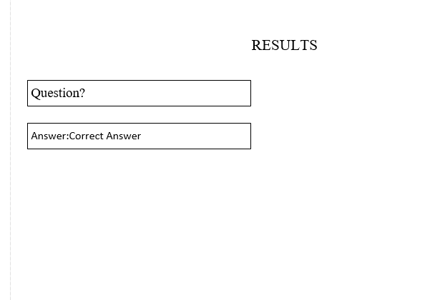

* **Architectural diagram:**

Architectural diagram for the project is as follows:

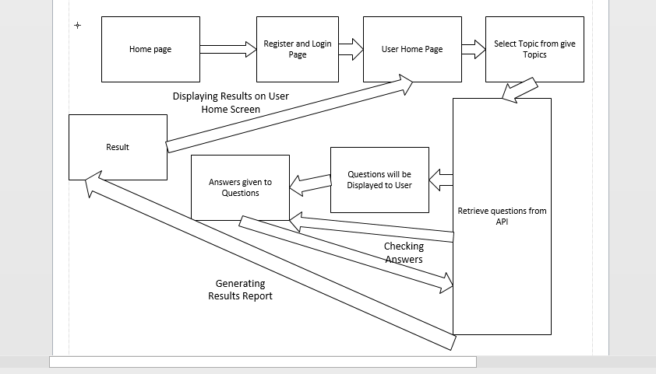

* **Sequence diagram:**

Sequence diagram for the project is as follows:

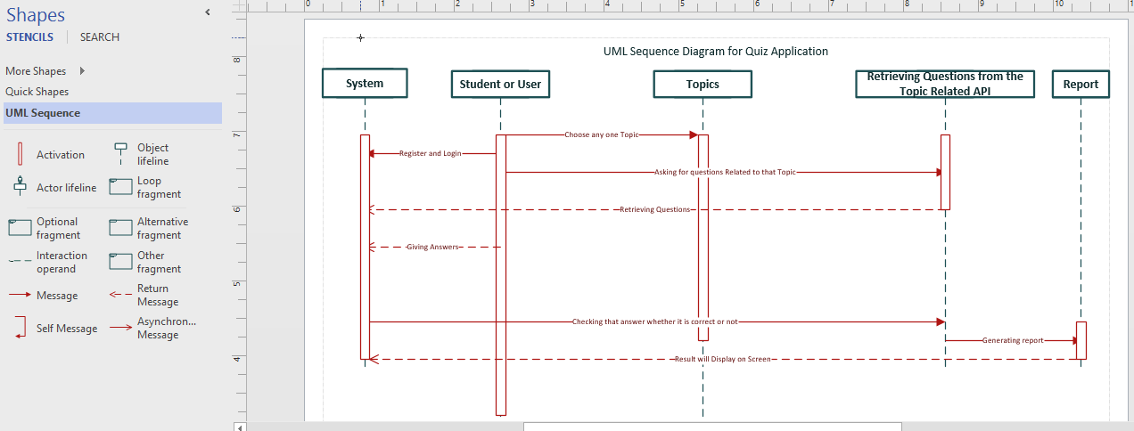

* **Class diagram:**

Class diagram for the project is as follows:

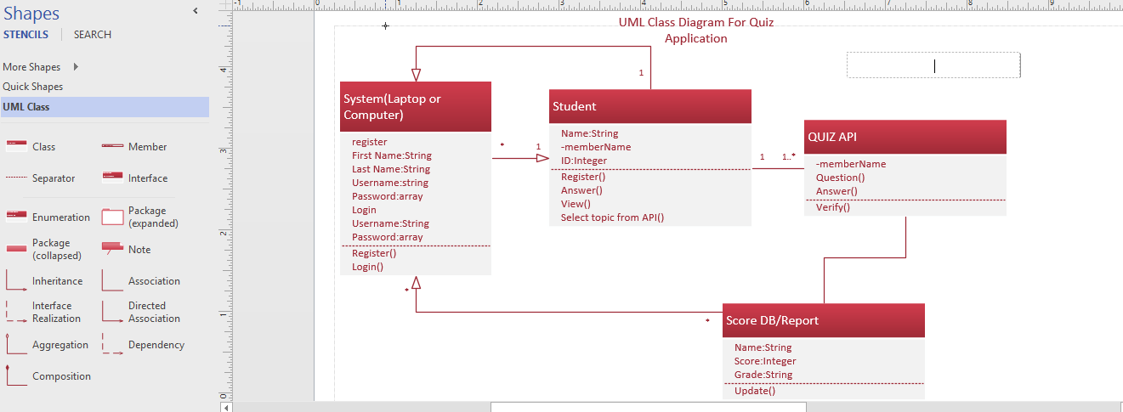

* **Activity diagram:**

Activity diagram for the project is as follows:

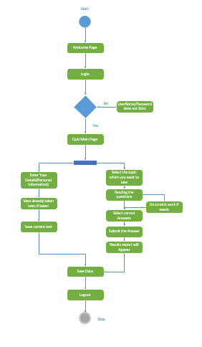

* **User story:**
* Students/users can take online quizzes through this Interactive quiz application.
* They can select any domain from the listed domains in the home page to take test.
* Users can listen to the questions/options by clicking them.
* Personal information is displayed in profile page.
* Test score is provided immediately after the quiz is completed.
* Users can assess their mistakes by the answers shown after the test.
* **Use case:**
* User must register himself/herself in the application.
* Upon successful registration user can login into the app.
* After logging in user has option to select domain among the domains listed.
* Upon selecting domain, user can take tests and view scores after completing the tests.
* **Service description:**
* Interactive quiz application provides quizzes to the users.
* Users can take tests and view results after the test.
* As results are provided instantly users can assess their mistakes.
* Users can listen to questions in the quizzes.
* Scribbling pad is provided for scratch work.

**Testing:**

The following are the unit test cases and their results:

|  |  |  |  |  |  |
| --- | --- | --- | --- | --- | --- |
| **S.No** | **Test case** | **Description/Process** | **Expected result** | **Actual result** | **Pass/Fail** |
| 1 | Registration | User has to register in registration page | Registration has to be successful | Registration is successful | Pass |
| 2 | Registration | Invalid email ID | Error has to be shown stating invalid email ID | Error has been shown stating invalid email ID | Pass |
| 3 | Registration | Password criteria must be met | Error has to be shown when password length criteria is not met | Error has been shown when password length criteria is not met | Pass |
| 4 | Log in | User has to login with valid credentials | Login has to be successful | Login successful | Pass |
| 5 | Home | User must select a topic for taking quiz | Quiz must start | Quiz has started | Pass |
| 6 | Quiz | User must answer a question to go to next question | Error has to be shown if user tries to go to next page without answering current page question. | Error has been shown when user tried to go to next page without answering current page question. | Pass |
| 7 | Quiz submission | User must submit quiz upon completion | After submission of the quiz test score has to be shown | After submission of the quiz test score has been shown | Pass |

**Deployment:**

Deployed code screenshots are attached below:

Registration page on web:

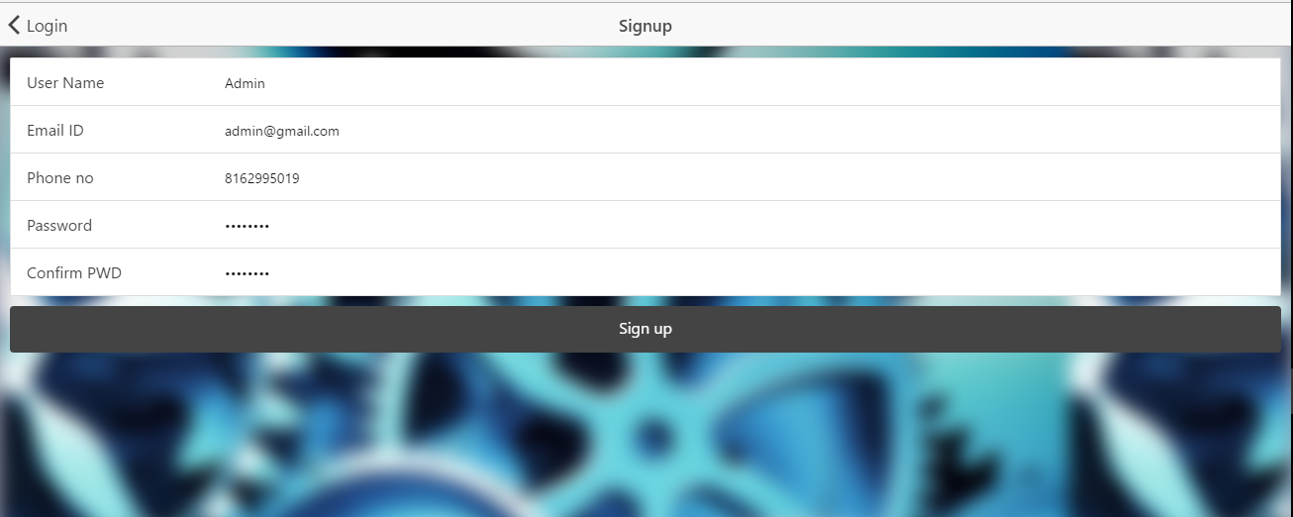

Registration page on mobile:

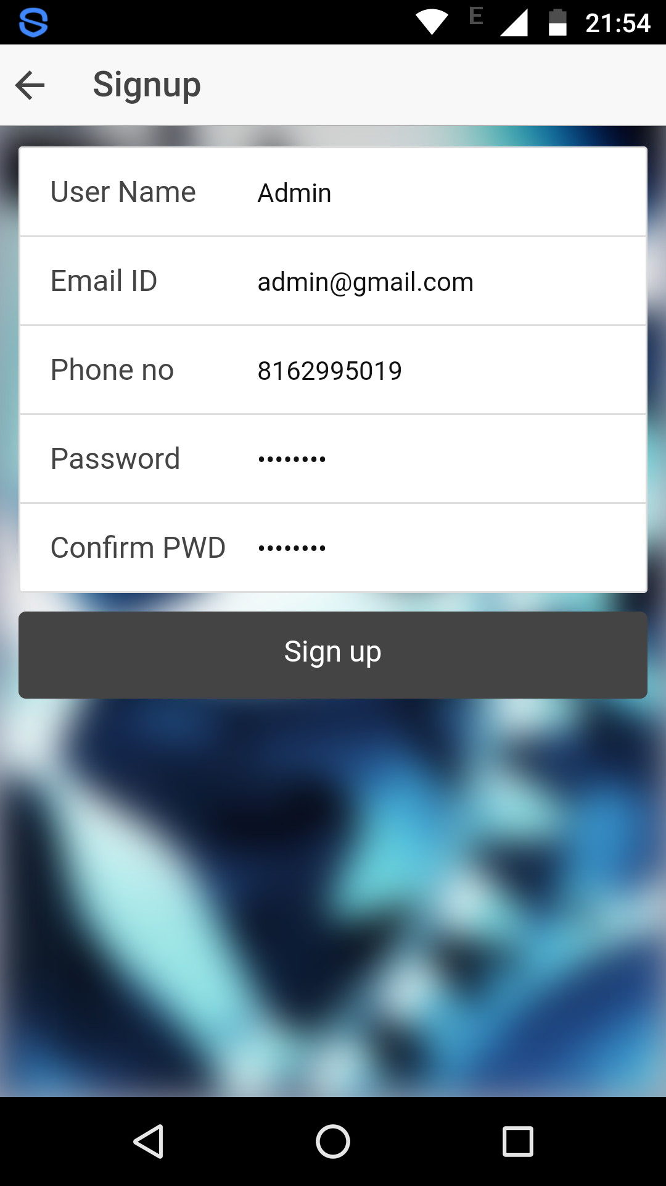

Registration successful on web:

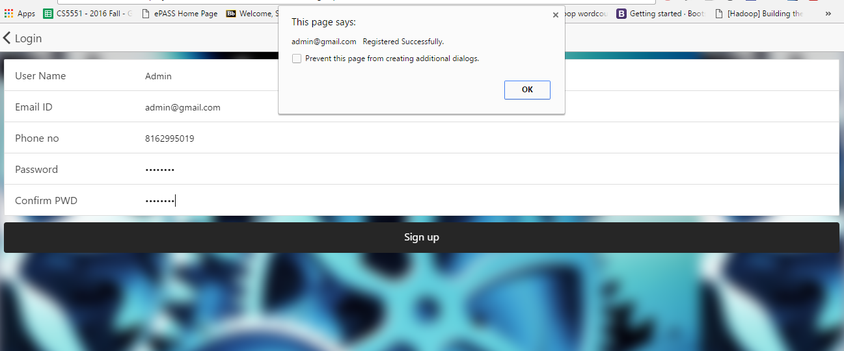

Registration successful on mobile:

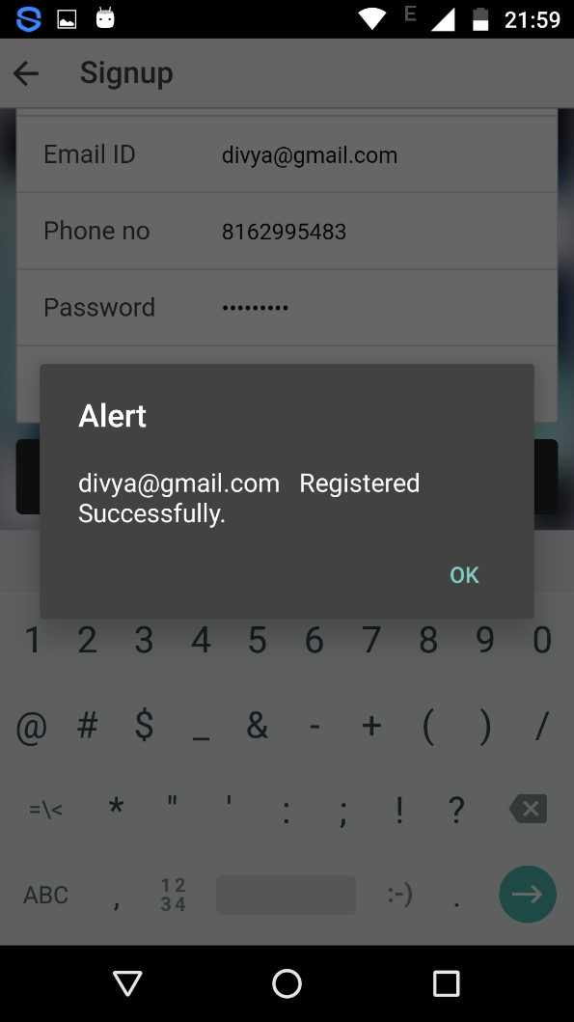

Login page on web:

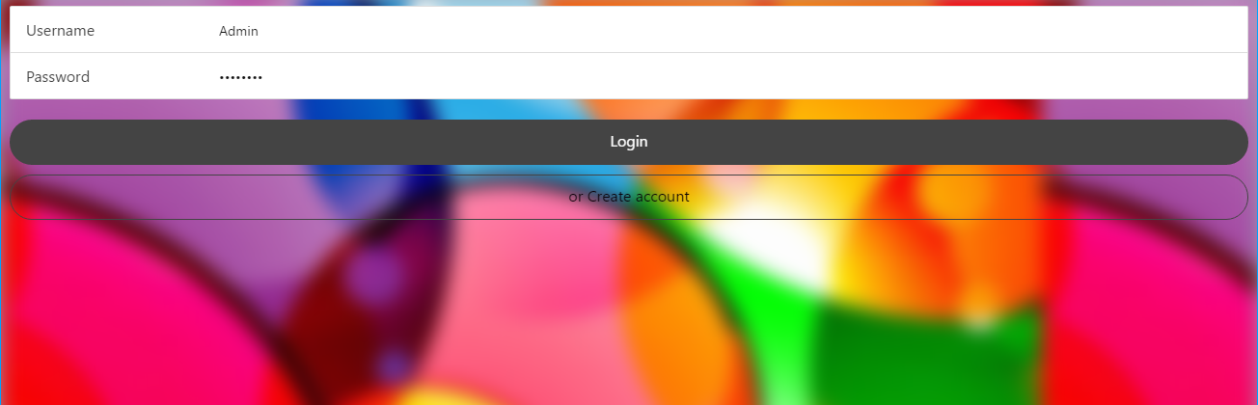

Login page on mobile:

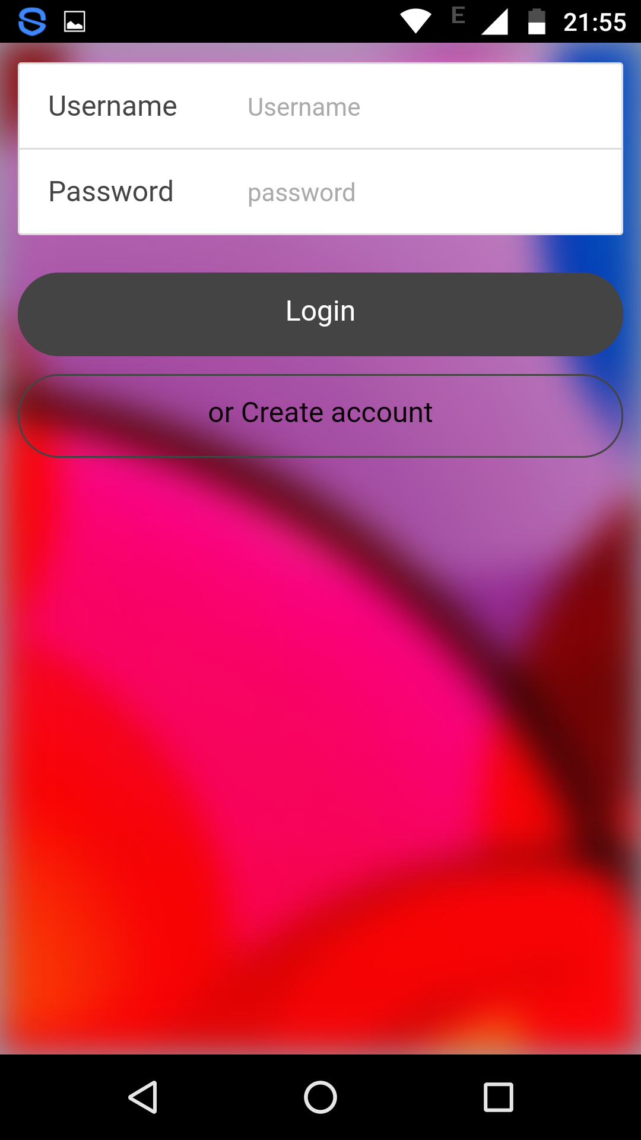

Home page on web:

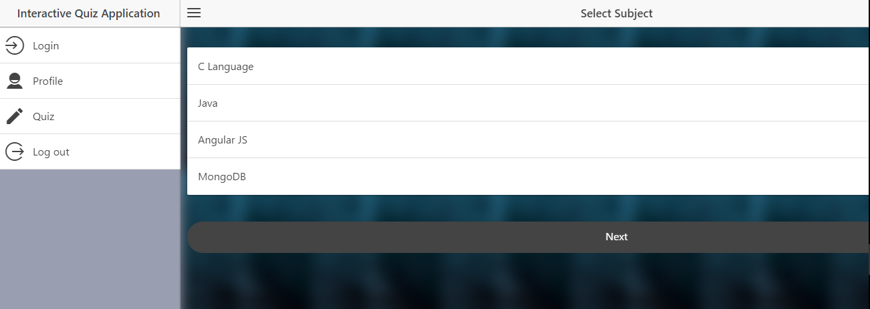

Home page on mobile:

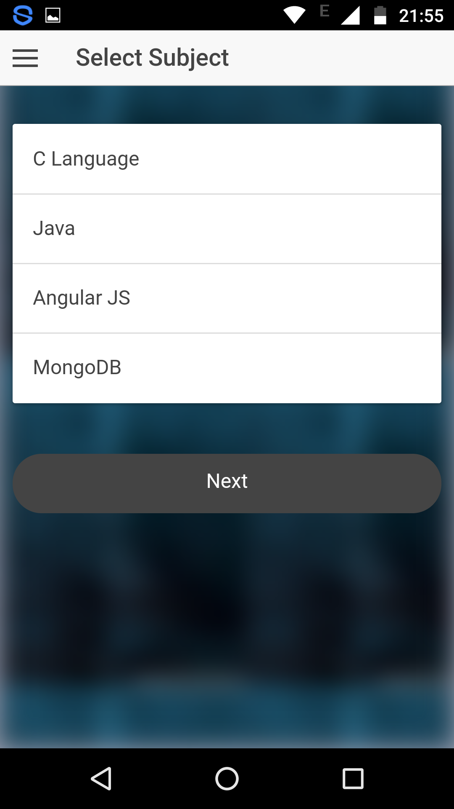

Quiz page on web:

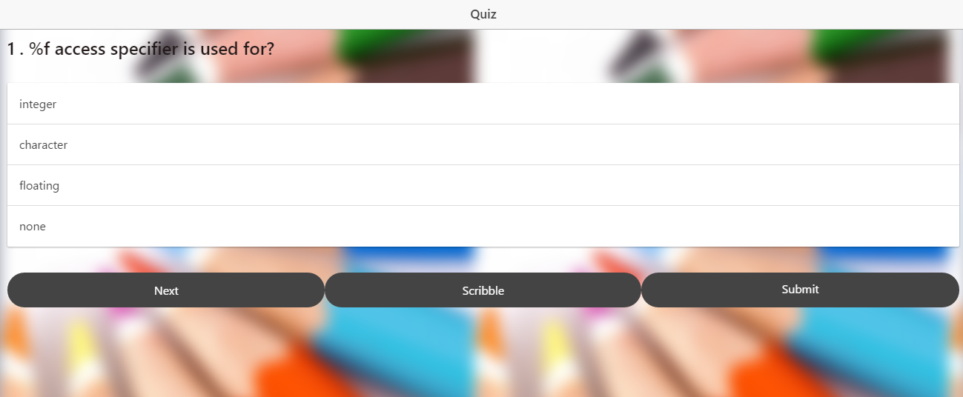

Quiz page on mobile:

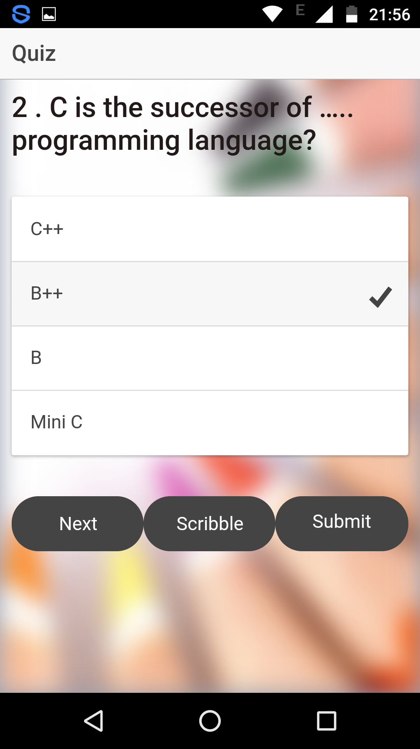

Score upon completion of quiz on web:

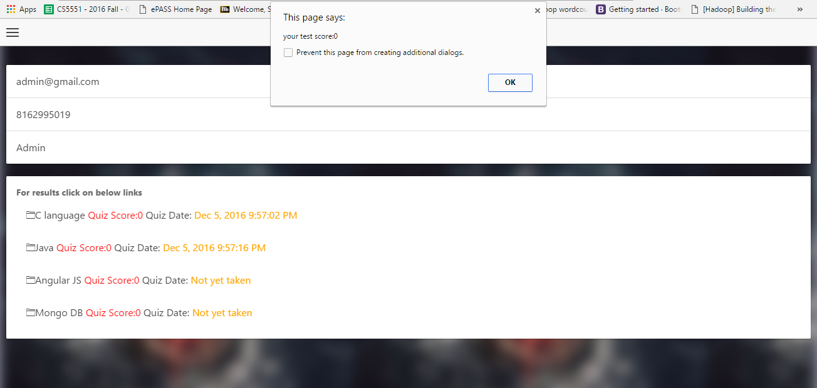

Score upon completion of quiz on mobile:

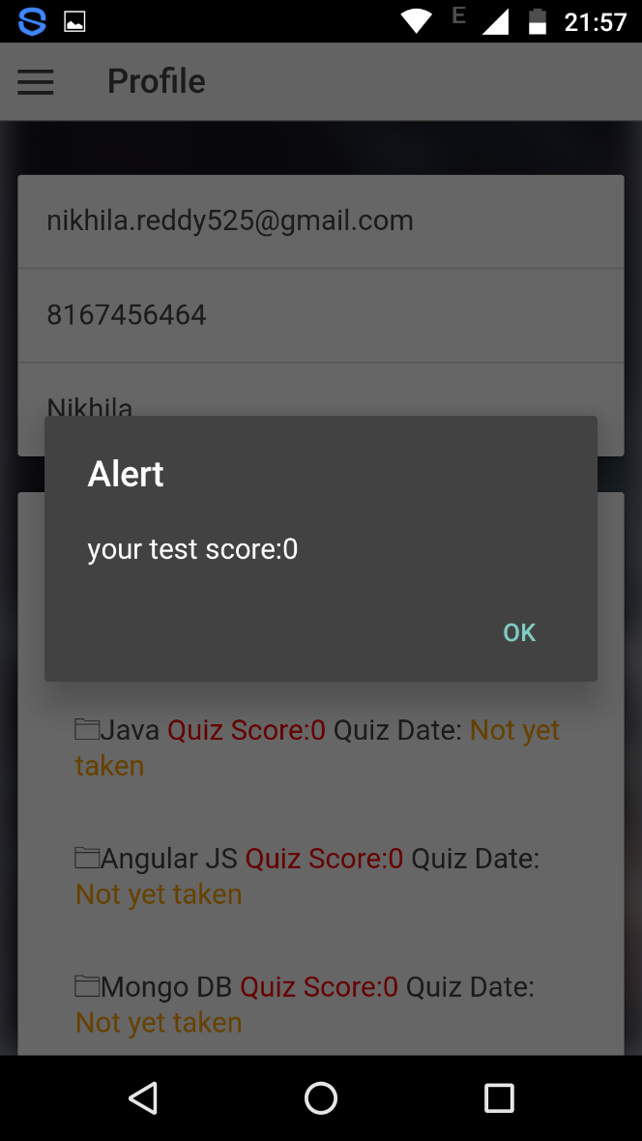

Attepted questions and answers after the test is done on web:

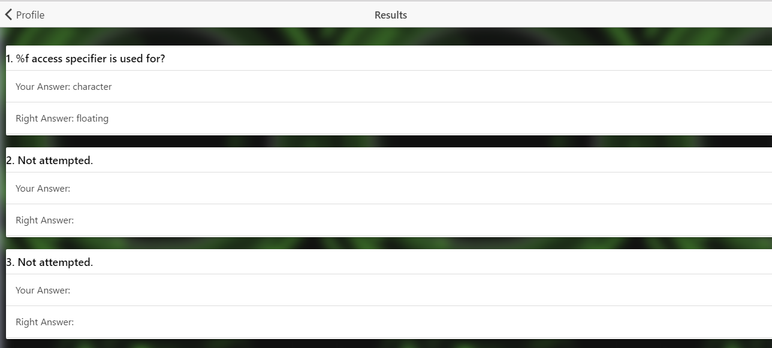

Attempted questions and answers after the test is done on mobile:

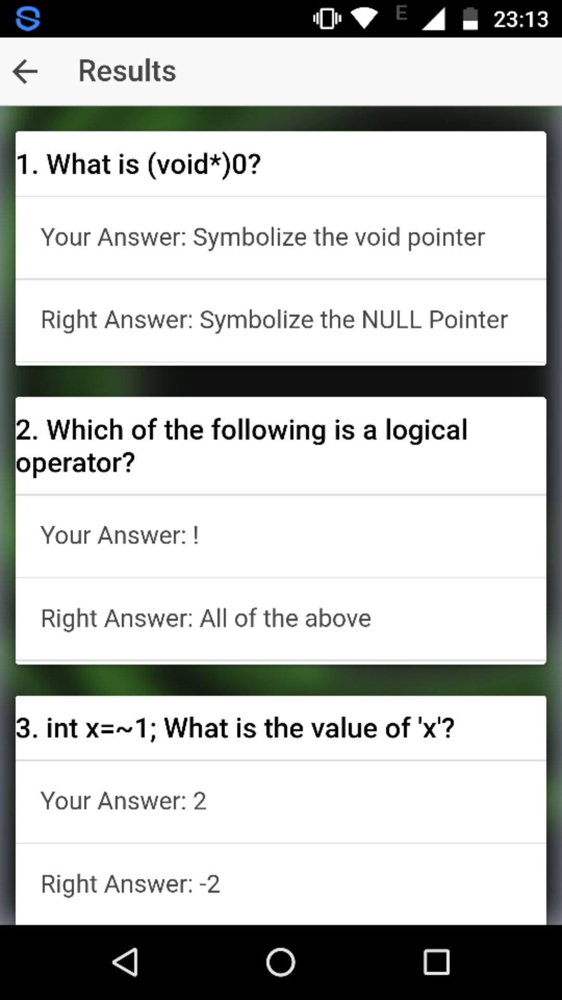

Profile page on web:

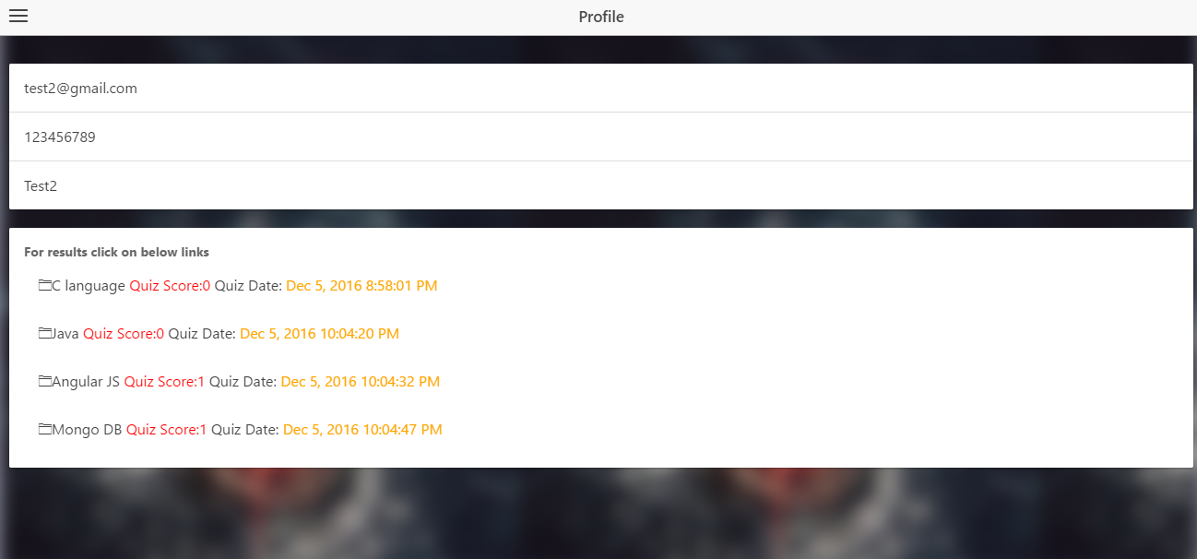

Profile page on mobile:

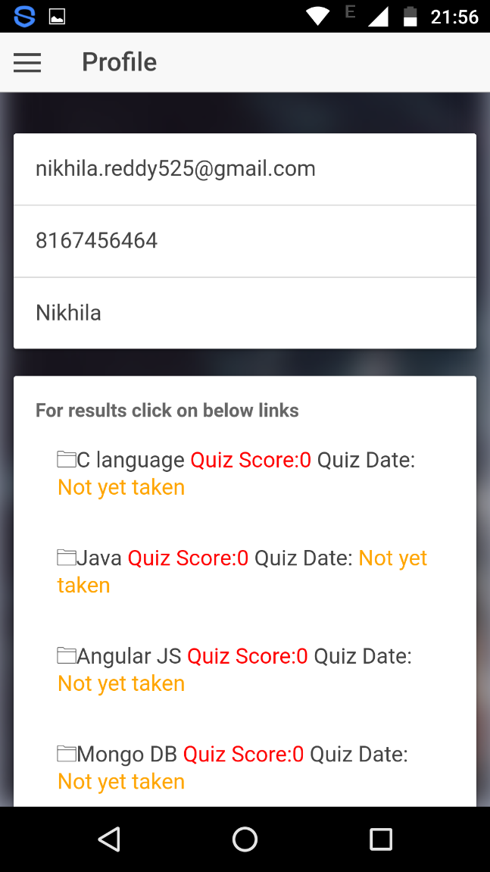

Invalid credentials on web:

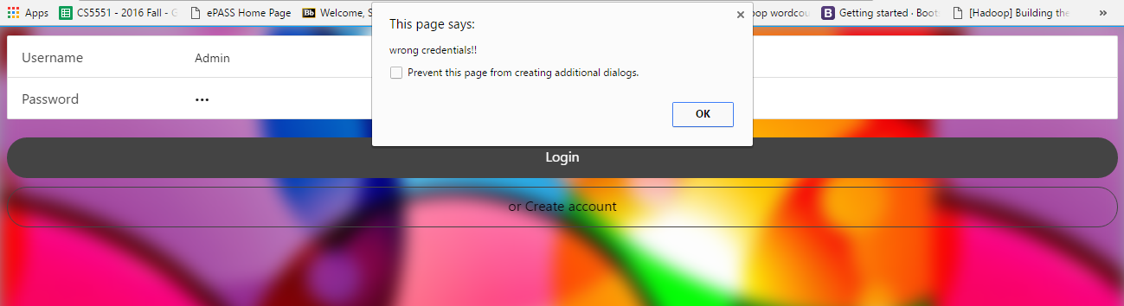

Invalid credentials on mobile:

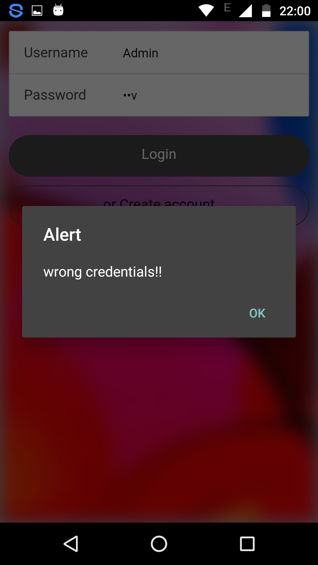

Scribbling pad on web:

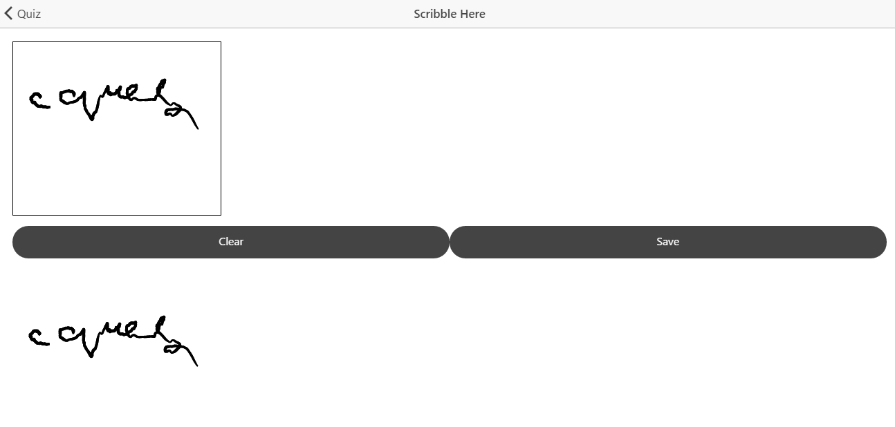

Scribbling pad on mobile:

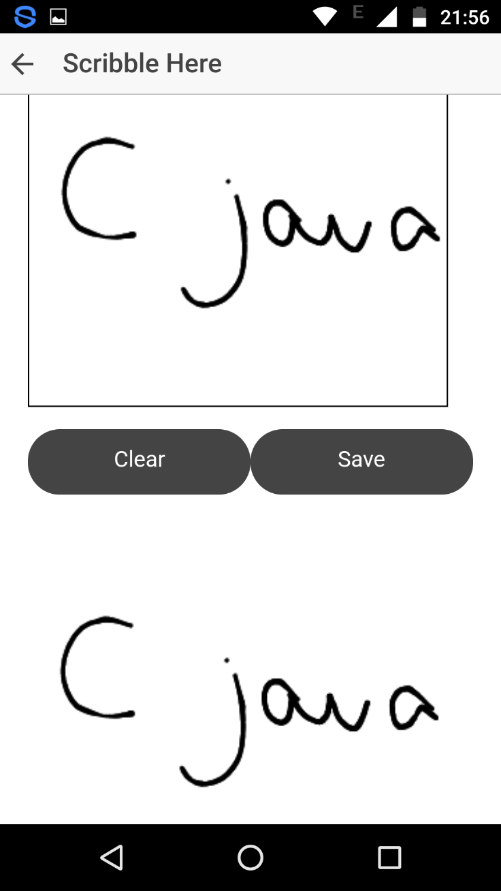

**Project Management:**

**Work completed:**

|  |  |  |  |  |
| --- | --- | --- | --- | --- |
| **S.No** | **Description** | **Responsibility** | **Time taken** | **Contributions** |
| 1 | Saving user’s quiz data once user submits the test, Tabs arrangement | Nikhila | 10 | 100% |
| 2 | Collection of questions to make quiz repository, Displaying latest test details | Divya | 10 | 100% |
| 3 | Display previous quiz taken, Display result upon completion of the quiz | SaiTeja | 10 | 100% |
| 4 | Quiz repository, Background images | Arun | 0 | 100% |
| 5 | Documentation | Nikhila, Divya, SaiTeja | 5 | 100% |

**Burn down chart:**

GitHub’s burn down chart of the project is as follows:

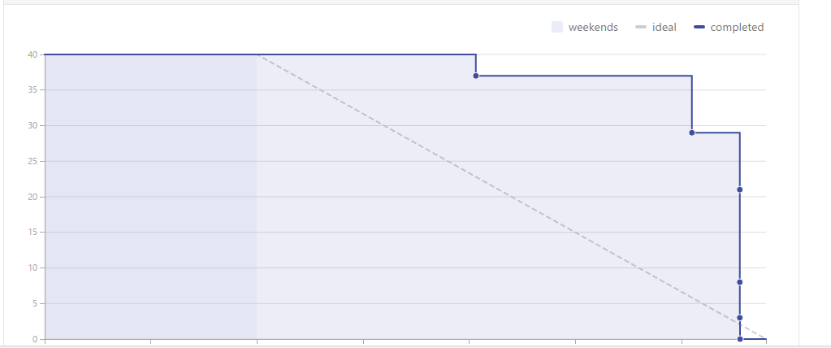

**Issues:**

GitHub’s issues for the project are as follows:

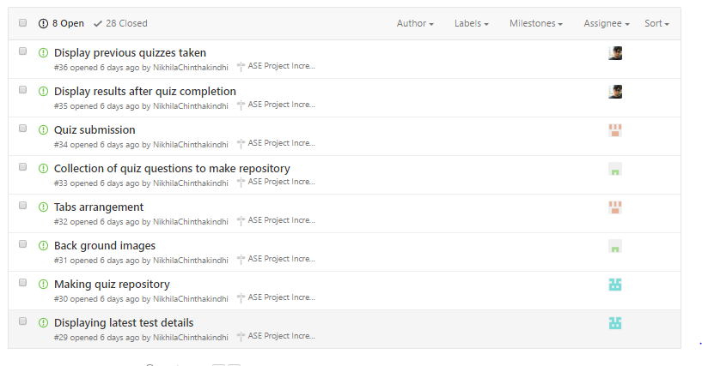

**Contributors graph:**

GitHub’s contributors graph for the project is as follows:

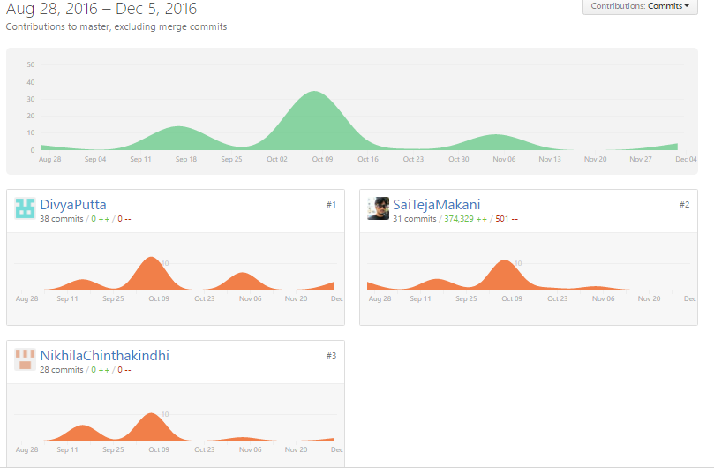

**Source code link:**

<https://github.com/SaiTejaMakani/ASE-Project/tree/master/SourceCode/ASE%20Project%20Increment4/ASEproject>

**PPT link:**

<https://docs.google.com/presentation/d/1poOdZl33yAU6gTEe9iGmeX3ikI2nIgQiameKURHFDWE/edit#slide=id.p3>

**Youtube vedio link:**

<https://www.youtube.com/watch?v=PGmo4uR5Y-0&feature=youtu.be>

**Bibliography:**

<https://developer.mozilla.org/en-US/docs/Web/API/SpeechSynthesisUtterance>

<http://www.w3schools.com/angular/>

<http://www.w3schools.com/bootstrap/default.asp>